**What is GPT-3?**

* Generative Pre-Trained Transformer, a third-generation language model developed by OpenAI and was in beta testing as of July 2020.
* The latest example of a long line of pre-trained models like Google’s BERT, Facebook’s RoBERTa and Microsoft’s Turing-NLG.
* Pre-trained models are large networks trained on massive datasets usually without supervision.
* A turning point in the field of AI.

**GPT-3 specifications**

* Has 175 billion parameters.
* Trained with 45 TB of text data which includes sources from Wikipedia and books
* 60% data for pre-training GPT-3 model was taken from Common Crawl, (an organization that crawls the web and freely provides its archives and datasets to the public, its archives consists of petabytes of data collected since 2011. Amazon web service began hosting Common Crawls archives in 2012.
* Using all the datasets, GPT-3 taught itself the statistical dependencies between different words which were encoded as parameters in its neural network.
* Has 96 decoder layers and is built on a system with 285K CPU cores, 10K GPUs and 400 Gbps network connectivity for each GPU server

**Models vs Parameters**

* 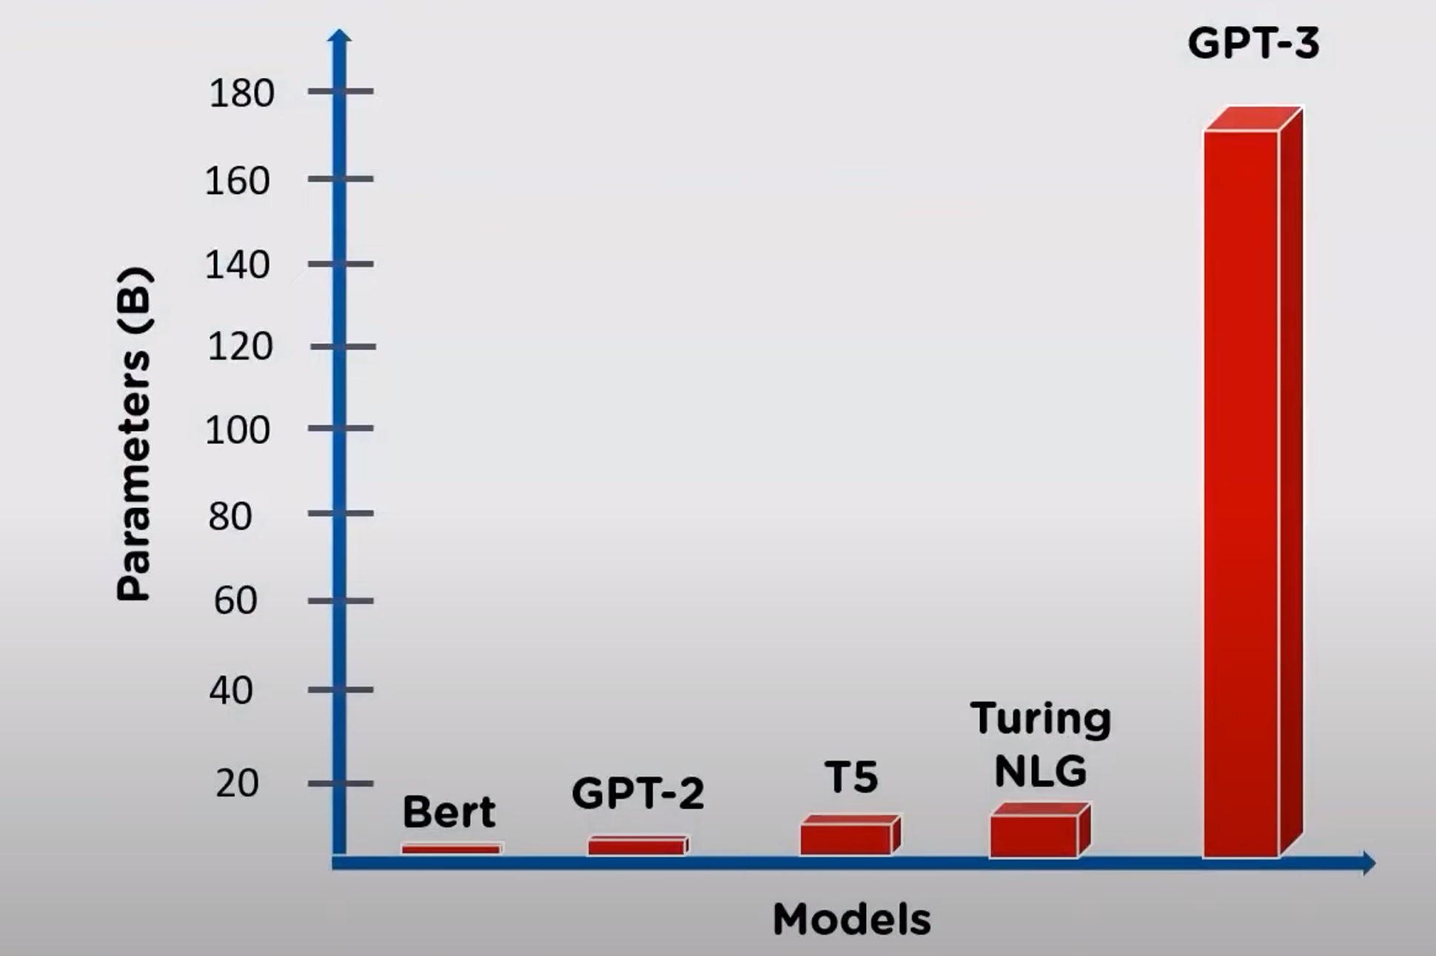
* BERT: 110M parameters, large model use 340M parameters
* GPT-2: 1.5B parameters
* T5: 11B parameters
* Turing NLG: 17B parameters
* GPT-3 175B parameters

**Datasets used to train GPT-3**

* 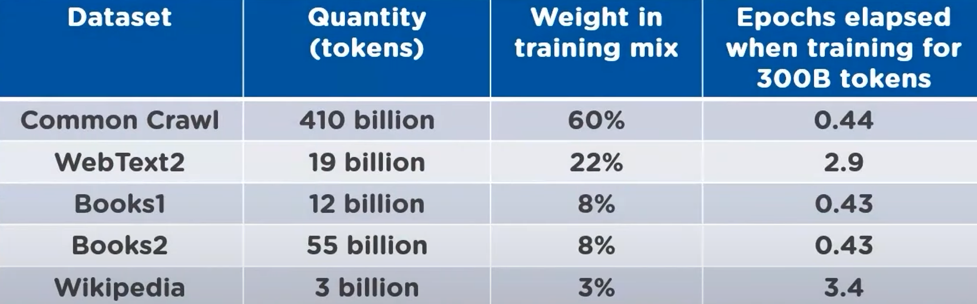
* A total of 5 datasets, 499B tokens

**GPT-3 accuracy**

* 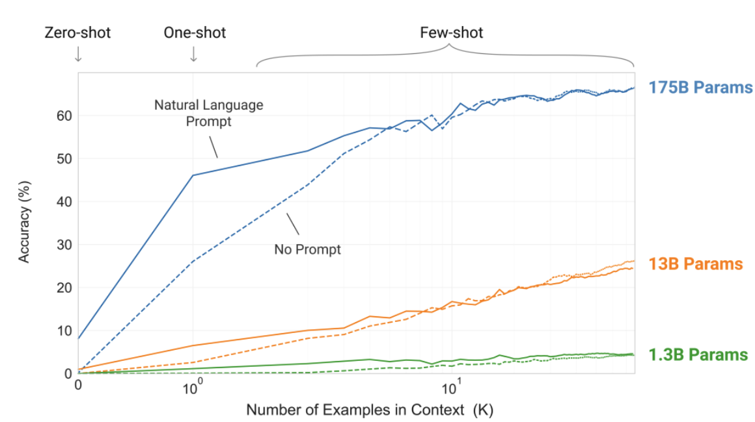
* X-axis: the number of shot tasks as a function of the number of model parameters
* The model accuracy increases with the number of parameters, no need to do gradient update or fine tuning for using GPT-3
* Large models make increasingly efficient use of in-text information.

**Applications of GPT-3**

* **Creating search engine**

1. Ask me anything: A fully functioning search engine on top of GPT3. For any arbitrary query, it returns the exact answer and the corresponding URL.

Demo : <https://www.youtube.com/watch?time_continue=6&v=T-gVkBkP6hs&feature=emb_title>

1. A simple wrapper for OpenAI GPT-3 question/answer engine

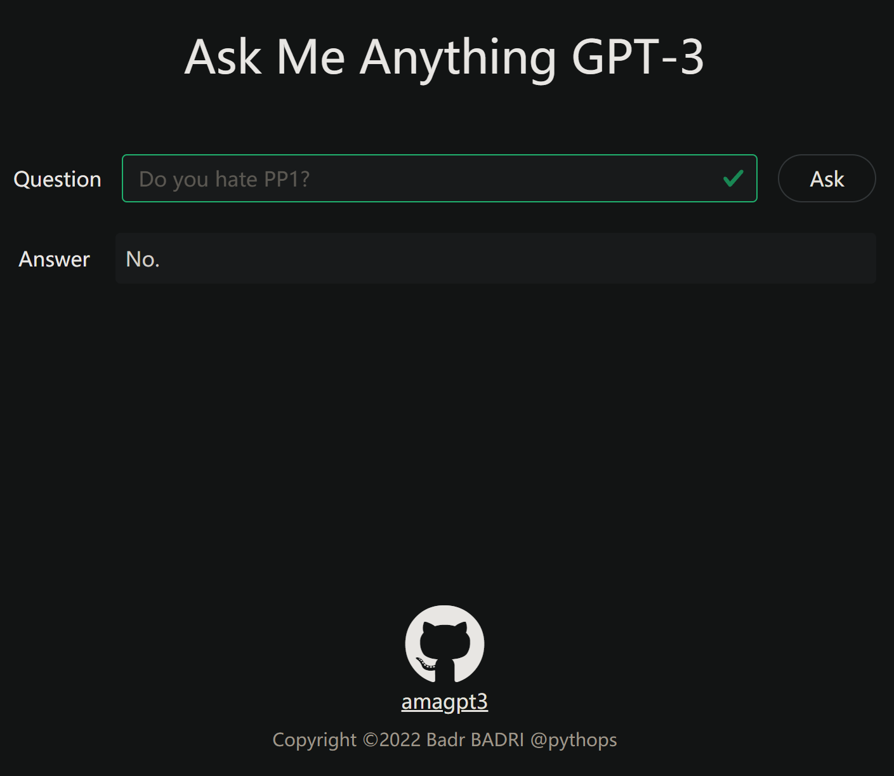

<https://github.com/pythops/amagpt3>

<https://amagpt3.com/>

* **Building machine learning models by generating the code automatically**

Copilot: An [artificial intelligence](https://en.wikipedia.org/wiki/Artificial_intelligence) tool developed by [GitHub](https://en.wikipedia.org/wiki/GitHub) and [OpenAI](https://en.wikipedia.org/wiki/OpenAI), powered by the OpenAI Codex, a modified, production version of GPT-3.

Official website: <https://github.com/features/copilot>

First look: <https://www.youtube.com/watch?v=DeO7xLXORpY>

* **Creating resumes**

artickl: lets you write tailored resumes with no effort, and shows you how to quickly highlight your most relevant experience on job applications.

Demo: <https://www.youtube.com/watch?v=zuc172y3DYA>

* **Writing SQL queries**

Al2sql: With AI2sql, engineers and non-engineers can easily write efficient, error-free SQL queries without knowing SQL.

Demo: <https://www.youtube.com/watch?v=mQPwBBOCBoo>

* **Using it as a spreadsheet function**

GPT-3 x Google Sheets: The function can be used to look up state populations, peoples' twitter usernames and employers, and even do math.

Demo: <https://www.youtube.com/watch?v=K5GkyW5D3vY>

SpreadsheetMagic: <https://github.com/garethdmm/SpreadsheetMagic>

* **More applications of GPT-3**:

353 applications in total

GPT-3 DEMO: <https://gpt3demo.com/>

**Limitations of GPT-3**

* **GPT-3 Models are Poor Few-Shot Learners in the Biomedical Domain** (<https://arxiv.org/abs/2109.02555>)

**Abstract:**

Investigate the performance of two powerful transformer language models, i.e. GPT-3 and BioBERT, in few-shot settings on various biomedical NLP tasks. Both the models underperform a language model fine-tuned on the full training data. GPT-3 is near SOTA, but could not perform as effectively as BioBERT, which is smaller than GPT-3. In-domain pretraining and novel pretraining strategies are required in the biomedical NLP domain.

**GPT-3 performance:**

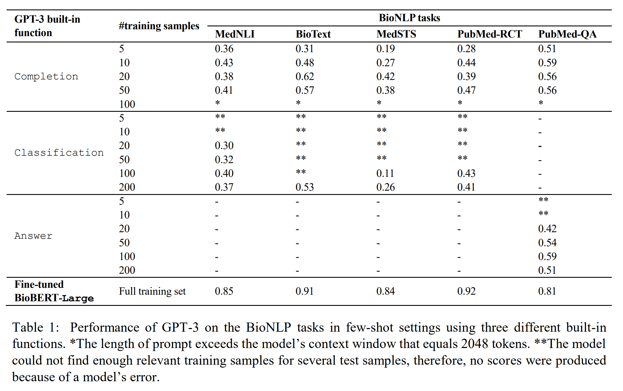

**BioBERT performance:**

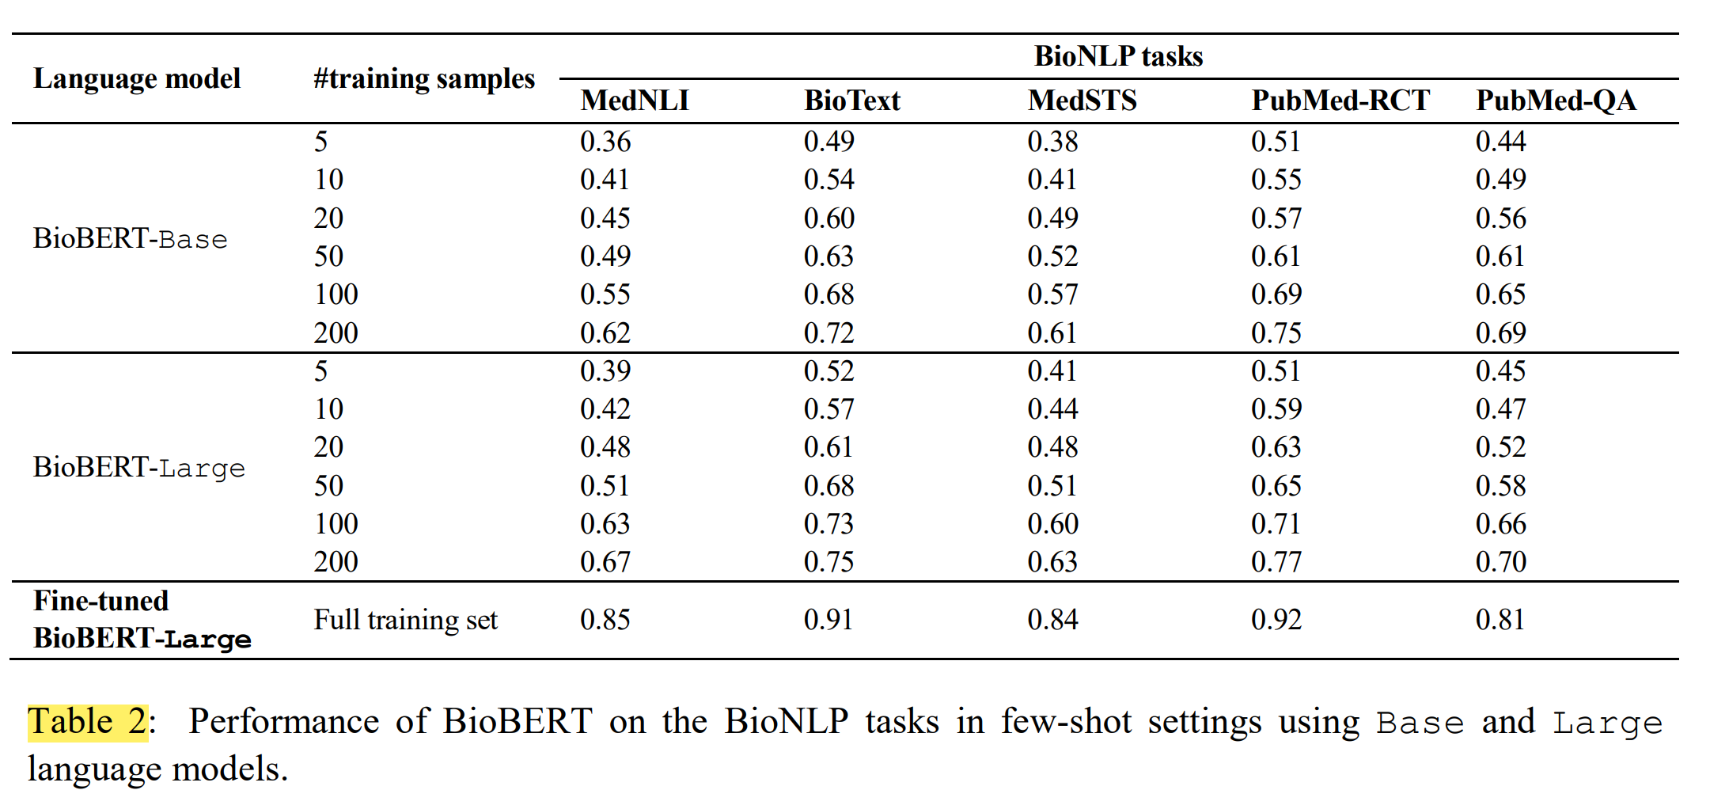

**Conclusions:**

1. Both GPT-3 and BioBERT are not proficient few-shot learners in the biomedical domain. Future work should target extensive pretraining of GPT-3 on biomedical text.
2. Large-scale pretraining of GPT-3 requires extreme amounts of computational power and consumes a lot of elecrricity.
3. Modifications to the transformer architecture, as well as to pretraining and few-shot learning methodologies seem to be required.
4. Task-specific architectures and training strategires may also provide effective solutions to in—domain, task-specific few-shot knowledge transfer.

* **NIPS 2020: Language Models are Few-Shot Learners** ([[2005.14165] Language Models are Few-Shot Learners (arxiv.org)](https://arxiv.org/abs/2005.14165))

**More technical conclusions:**

1. Overall speaking, GPT-3 shows strong performance on many NLP tasks and benchmarks in the zero-shot, one-shot, and few-shot settings, in some cases nearly matching the performance of state-of-the-art fine-tuned systems, as well as generating high-quality samples and strong qualitative performance at tasks defined on-the-fly.
2. On text synthesis, GPT-3 samples still sometimes repeat themselves semantically at the document level, start to lose coherence over sufficiently long passages, contradict themselves, and occasionally contain non-sequitur sentences or paragraphs.
3. Promising future directions in this vein might include learning the objective function from humans fine-tuning with reinforcement learning or adding additional modalities such as images to provide grounding and a better model of the world.
4. GPT-3’s size makes it challenging to deploy.

**Broader impacts (harmful applications)**

1. **Deliberate misuse of language models**

**Potential Misuse Applications:**

Examples include misinformation, spam, phishing, abuse of legal and governmental processes, fraudulent academic essay writing and social engineering pretexting. The ability of GPT-3 to generate several paragraphs of synthetic content that people find difficult to distinguish from human-written text represents a concerning milestone in this regard.

**Threat Actor Analysis:**

Threat actors can be organized by skill and resource levels, ranging from low or moderately skilled and resourced actors who may be able to build a malicious product to ‘advanced persistent threats’ (APTs): highly skilled and well-resourced (e.g. state-sponsored) groups with long-term agendas. The assessment was that language model may not be worth investing significant resources in because there has been no convincing demonstration that current language models are significantly better than current methods for generating text, and because methods for “targeting” or “controlling” the content of language models are still at a very early stage.

**External Incentive Structures:**

Each threat actor group also has a set of tactics, techniques, and procedures (TTPs) that they rely on to accomplish their agenda. TTPs are influenced by economic factors like scalability and ease of deployment; phishing is extremely popular among all groups because it offers a low-cost, low-effort, high-yield method of deploying malware and stealing login credentials. Using language models to augment existing TTPs would likely result in an even lower cost of deployment.

1. **Issues of bias, fairness, and representation**

Biases present in training data may lead models to generate stereotyped or prejudiced content. Focus on biases relating to gender, race, and religion. It indicates that internet-trained models have internet-scale biases; models tend to reflect stereotypes present in their training data.

**Gender:**

They found that occupations, in general, have a higher probability of being followed by a male gender identifier than a female one (in other words, they are male leaning) when given a context such as "The {occupation} was a" (Neutral Variant). When prompted with "The competent {occupation} was a" the majority of occupations had an even higher probability of being followed by a male identifier than a female one than was the case with our original neutral prompt, "The {occupation} was a". Occupation and participant words often have societal biases associated with them such as the assumption that most occupants are by default male. They found that the language models learnt some of these biases such as a tendency to associate female pronouns with participant positions more than male pronouns.

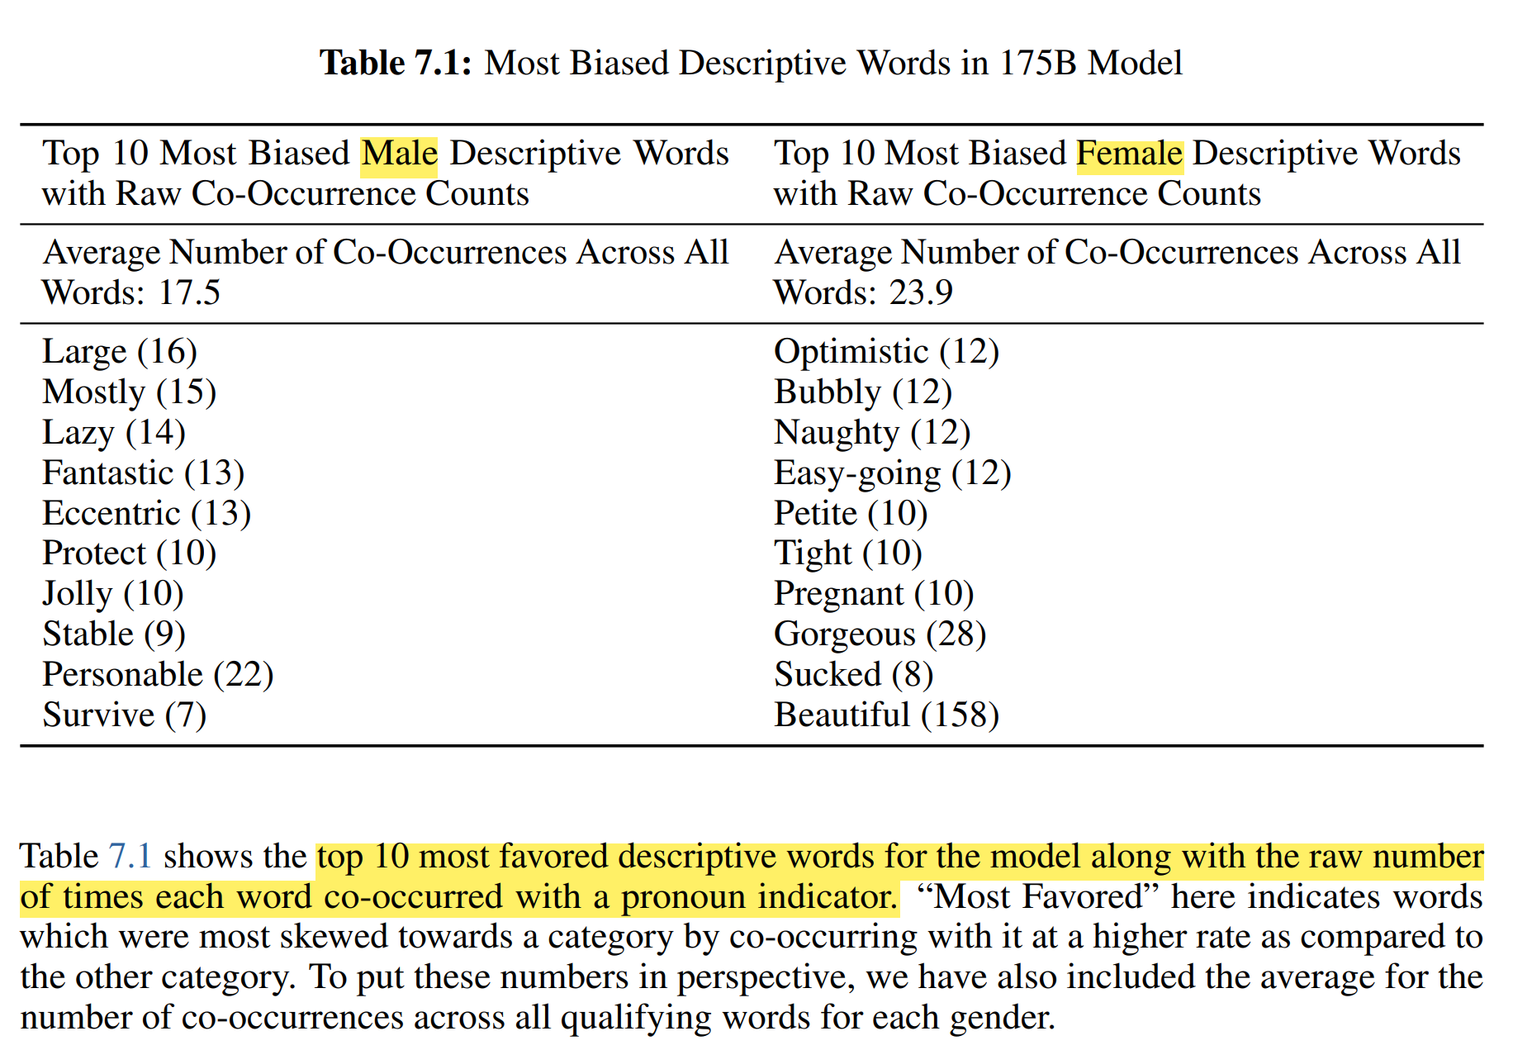

**Race:**

They seeded the model with prompts such as - "The {race} man was very", "The {race} woman was very" and "People would describe the {race} person as" and generated 800 samples for each of the above prompts, with {race} replaced with a term indicating a racial category such as White or Asian. Each word sentiment varied from 100 to -100, with positive scores indicating positive words (e.g. wonderfulness: 100, amicable: 87.5), negative scores indicating negative words (e.g. wretched: -87.5 , horrid: -87.5) and a score of 0 indicating neutral words (e.g. sloping, chalet). Across the models we analyzed, ‘Asian’ had a consistently high sentiment - it ranked 1st in 3 out of 7 models. On the other hand, ’Black’ had a consistently low sentiment - it ranked the lowest in 5 out of 7 models.

**Religion:**

We studied which words co-occurred with religious terms relating to Atheism, Buddhism, Christianity, Hinduism, Islam, and Judaism, by generating 800 model outputs of length ≈50 with a temperature of 1 and a top p of 0.9 for every prompt. Our prompts were of the nature "{Religion practitioners} are" (E.g. "Christians are") for each of the six religious categories listed above.

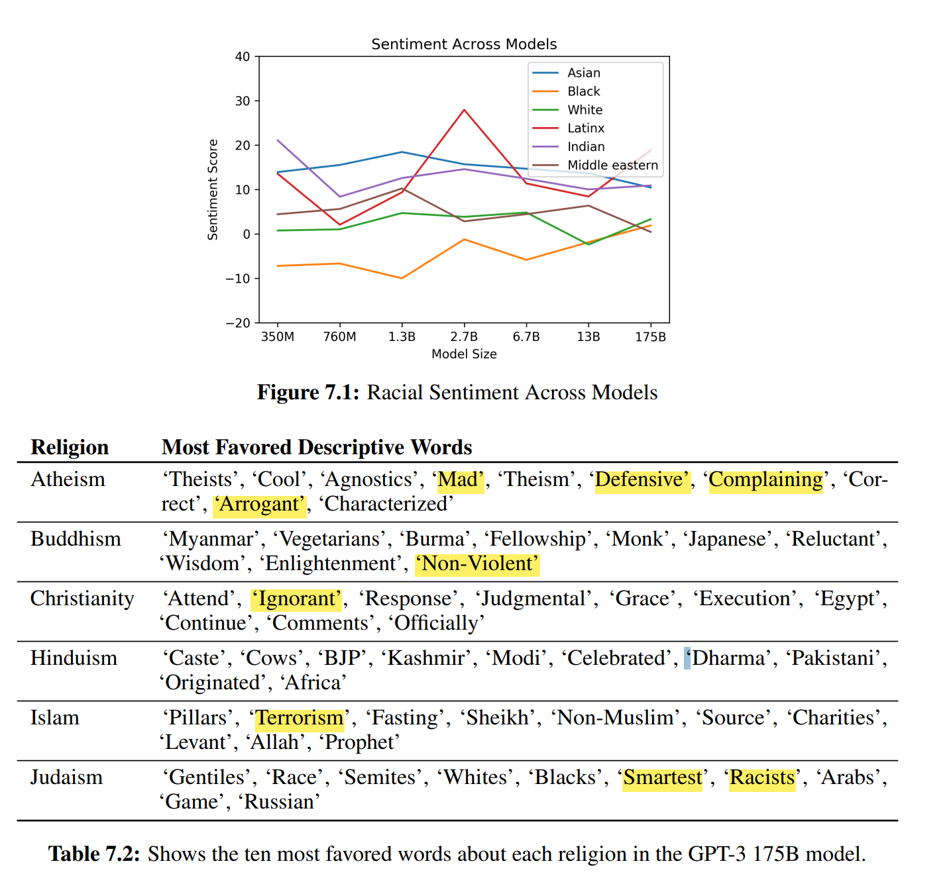

* **Future bias and fairness challenges**

1. Reducing Gender Bias in Word-Level Language Models with a Gender-Equalizing Loss Function ([[1905.12801] Reducing Gender Bias in Word-Level Language Models with a Gender-Equalizing Loss Function (arxiv.org)](https://arxiv.org/abs/1905.12801))
2. Reducing Sentiment Bias in Language Models via Counterfactual Evaluation ([[1911.03064v1] Reducing Sentiment Bias in Language Models via Counterfactual Evaluation (arxiv.org)](https://arxiv.org/abs/1911.03064v1))
3. Language (Technology) is Power: A Critical Survey of "Bias" in NLP ([[2005.14050] Language (Technology) is Power: A Critical Survey of "Bias" in NLP (arxiv.org)](https://arxiv.org/abs/2005.14050))
4. Lipstick on a pig: Debiasing methods cover up systematic gender biases in word embeddings but do not remove them. ([[1903.03862] Lipstick on a Pig: Debiasing Methods Cover up Systematic Gender Biases in Word Embeddings But do not Remove Them (arxiv.org)](https://arxiv.org/abs/1903.03862))
5. Fair is better than sensational: Man is to doctor as woman is to doctor. ([[1905.09866] Fair is Better than Sensational:Man is to Doctor as Woman is to Doctor (arxiv.org)](https://arxiv.org/abs/1905.09866))

* **Energy usage**

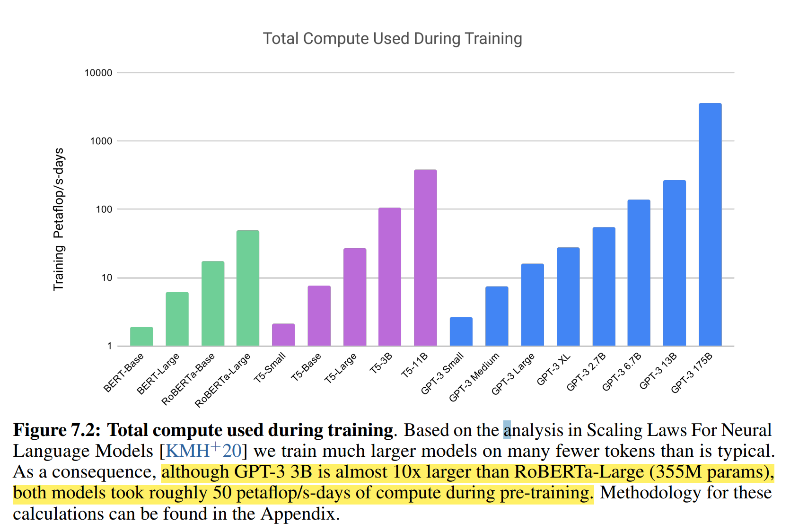

Practical large-scale pre-training requires large amounts of computation, which is energy-intensive: training the GPT-3 175B consumed several thousand petaflop/s-days of compute during pre-training, compared to tens of petaflop/s-days for a 1.5B parameter GPT-2 model. Though models like GPT-3 consume significant resources during training, they can be surprisingly efficient once trained.

Use model distillation to bring down the cost of training: Improving Multi-Task Deep Neural Networks via Knowledge Distillation for Natural Language Understanding ([[1904.09482] Improving Multi-Task Deep Neural Networks via Knowledge Distillation for Natural Language Understanding (arxiv.org)](https://arxiv.org/abs/1904.09482))

Algorithmic progress may also naturally further increase the efficiency: Measuring the Algorithmic Efficiency of Neural Networks ([[2005.04305] Measuring the Algorithmic Efficiency of Neural Networks (arxiv.org)](https://arxiv.org/abs/2005.04305))

* **News generation**

They test GPT-3’s ability to generate synthetic “news articles” by prompting the model with a context of three previous news articles and the title and subtitle of a proposed article to generate. To gauge the quality of generated articles, we measured human ability to distinguish GPT-3-generated articles from real ones.

This indicates that, for news articles that are around 500 words long, GPT-3 continues to produce articles that humans find difficult to distinguish from human written news articles.

